March 17, 2023

Dracott, Percy

HILLS rOAD

MultiPlayer Creative Sandbox

Table of Contents

Analysis2

Type chapter title (level 2)2

Type chapter title (level 3)3

Documented Design11

Type chapter title (level 2)5

Type chapter title (level 3)6

Technical Solution4

Type chapter title (level 2)5

Type chapter title (level 3)6

Testing4

Type chapter title (level 2)5

Type chapter title (level 3)6

Evaluation4

Type chapter title (level 2)5

Type chapter title (level 3)6

Analysis

**Project Overview**

In this project, I will be exploring a Solution to a problem, to fulfil the needs of my client. Video game, since their creating have been a means of socialising, connecting and relaxing. A recent boom in popularity, owing to people spending more time gaming since the recent Covid-19 pandemic and lockdowns, has resulted in games becoming a staple in many people’s lives. This ever-growing popularity creates a strong demand for new and unique games to enjoy.

**Project Outline**

My client is an avid video game enjoyer, who like many enjoy the social aspect of video games. They require a multiplayer game in the “Creative Sandbox” genre, so that they can play and create with their friends.

While this may be available through other games, their requirements for a game that runs well on very low powered hardware so that they can run the game on their laptops in a LAN configuration, vastly limits the choices of game. This excludes games such as terraria or Minecraft.

With all this in mind, the client has made it clear that they want a complicated and optimised map generation algorithm as well as multiplayer capability, as connecting on the same session is the most core component, and the most decorated feature.

**My Client**

My client in question is an avid video game fan. They particularly like retro style games, with simple and well executed features.

**An Interview with Elliot - My Client**

1. How would you like the game to be played?

A1: The Game needs to be playable on PC, as my friends and I all have laptops which we play our games on. Therefore, the controls need to be suited to a keyboard and mouse, and with a trackpad friendly control scheme.

1. How would you like the game to be used and by who?

A2: The game will be played by me and my friends using multiplayer. In either a LAN with all players on my Wi-Fi, or over a WAN hosted by me as I know how to set my router up for Port-Forwarding.

1. Which aspects of a “Creative Sandbox” do you find most enjoyable?

A3: For me I find the building aspect of the game most enjoyable. Coming up with an idea for a build. then creating it in ‘reality’ most appeals to me. I also enjoy exploring the game world, as I can often find inspiration of new builds in the landscape.

1. Which features would you most associated with a “Creative Sandbox”?

A4: In my opinion, gathering recourses for a build through mining is a key feature of a creative game. As it rewards the player with a real sense of achievement and satisfaction, knowing the work it takes to complete their build. I also enjoy the sense of progression, as getting new tools makes once difficult tasks seem trivial.

1. Which areas of a “Creative Sandbox” map are you most interested in?

A5: Of course, the landscape of a map is important, as much of the gameplay occurs there. However, I find exploring the thrill of exploring cave systems in games to be the most enjoyable.

**Objectives**

1. Have functioning game element, which:
   1. Allows the player to move around the world,
   2. Contains hostile Mobile-Entities (mobs) in the world,
   3. Has some form of combat between the player and the mobs,
   4. Has a unique procedurally generated terrain and cave system,
   5. Has a destructible world where blocks can be mined by the player,
   6. Has a building system where the player can build structures,
2. Have a randomly generating map, which:
   1. Is randomly generated at game start,
   2. Has a tunnelling cave generation algorithm,
   3. Has randomly generated trees,
3. Have a functioning Menu System, which:
   1. Allows for new games to be created,
   2. Allows for players to connect online,
   3. Displays the game title,
   4. Allows the user to close the program,
4. Have a functioning Multiplayer System, which:
   1. Allows multiple players to play in the same world,
   2. Allows the world to be synced across each player,
   3. Allows interactions between players,
   4. Allow players to connect through LAN or WAN
5. Satisfy the clients brief by:
   1. Have a save-able and load-able world,
   2. Have a Day / Night cycle,
   3. Include fantasy mobs such as skeletons, or zombies,
   4. Be playable on PC,
   5. Be playable on a mouse and keyboard or trackpad,
6. Be appealing to my End-Users by:
   1. Having a consistent art style throughout,
   2. Using a consistent pixel by pixel tile size throughout,

**Similar Games**

In order to create my program and explore possible features, I have researched into 2 existing “Creative Sandbox” games. Minecraft and Terraria.

|  |  |
| --- | --- |
| Minecraft | Terraria |
| * Made for PC and other platforms.= * 3D * Able to create LAN multiplayer games, however there’s no inbuilt way to play WAN multiplayer for free. * Uses 16x16 pixel art style. * Procedurally generated map with cave system. | * Made of PC and other platforms * 2D * Can create free multiplayer games. * Uses pixel art textures. * Side Scroller * Items to enhance your character. |

**Research**

From these nots I have devised that me “Creative Sandbox” game will:

* Be a side-scrolling 2D game, to reduce computational load on a system.
* Use Keyboard and Mouse/Trackpad controls.
* Feature pixel art graphics (8p8px).
* Have free WAN multiplayer capability.
* Include a uniquely generating map and cave system.
* Include crafting/progression to enhance a player’s character.
* Include game saving where the world can be saved and loaded from the server.

Additional Advanced Features

* Be able to save and load player inventories.

My solution will require two applications, a server and client. My client will run the server application and then, they can connect using client applications.

**Outline of Solution**

Random Map Generation

To meet the clients brief, I will be making use of random map generation, meaning that a uniquely generated map can be made for each new game. In order to do this, I will need to find a way to randomly generate a map.

Although, Minecraft is a 3D game its’ early beta methods for world generation are great to analyse. As it is made for 3D, an altered 2D version of its’ system producing a single slice would be highly efficient. For my research of Procedural generation therefore, I will have researched the solution used by beta versions of Minecraft. Minecraft uses a Perlin noise function to give the height at each given coordinate, in addition to many other functions to add trees and caves when creating a map. As my game will be 2D I will have to research other methods of generation of cave systems and other world features. For cave generation, I will produce a prototype to explore different generation methods; giving me a chance to analyse and evaluate each solution. In this I will explore both a Perlin noise approach and an iterative cellular automata approach.

Multiplayer

For multiplayer I will be using Riptide Networking through Unity, I chose this as it offers a high degree of control of network entities through code, with open-source code. For my client, I will produce two applications, a server and client build. With clients many clients connecting to one server. Clients will have to send the position of their player to the server as player movement will be managed client side. Ordinarily this is a bad idea for a multiplayer game, as this makes cheating much easier; a cheater can simply change the data in messages sent to the server, however Elliot has said that this won’t be a problem as only a few trusted friends will have access to the game. As well as this, managing movement client side will spread the processing load across multiple systems in a thick-client type solution, reducing the load placed on the computer running the server application, Elliot notes that he is likely to run both the client and server applications simultaneously on his laptop and therefore optimisation of the networking side is key.

**World Generation Prototype**

In this prototype, terrain generation is implemented using Perlin noise, by giving the function the x-coordinate and a seed value instead of a y-coordinate, for each value of x. This produces a smooth and varied terrain, before using Perlin noise I had experimented with using a Sin() based function to generate terrain, however this led to a far too periodic looking terrain with repeating hills and few areas of flat land. Elliot says it’s important for varied terrain to keep worlds looking interesting, however having a few flatter spaces is ideal for building.

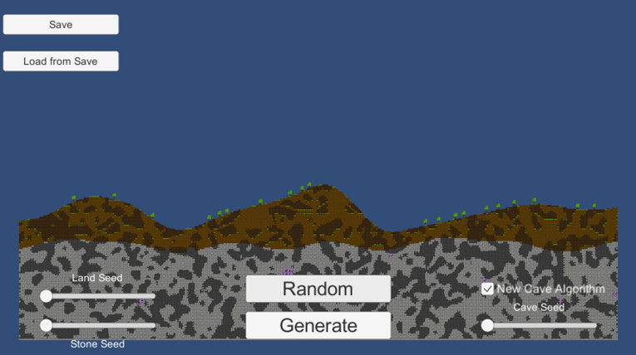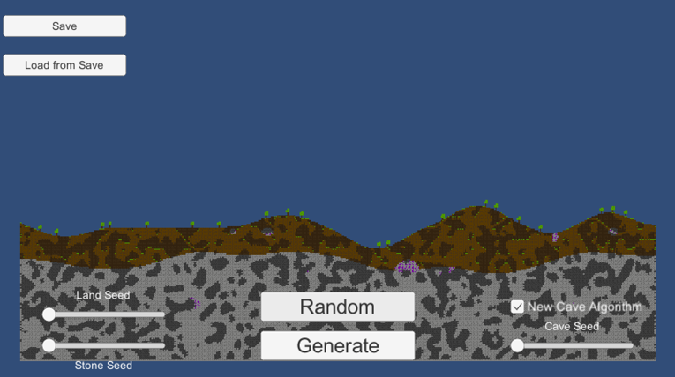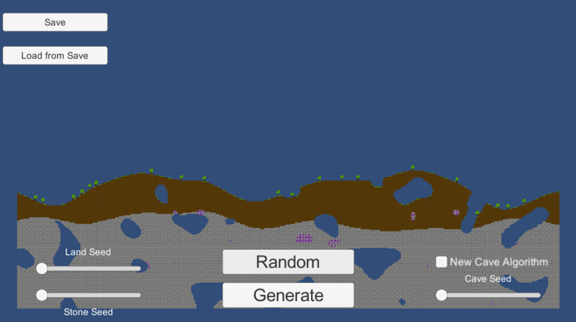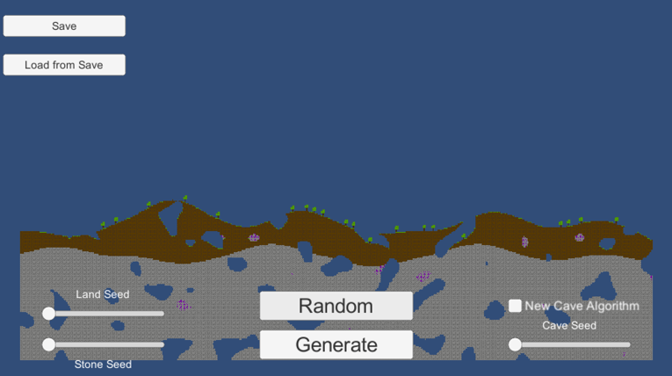

Trees are added randomly, using a random integer value for the x-position, then checked for collisions to prevent trees from spawning onto of each other.

The first two screenshots show a cellular automata approach to cave generation. This code will be explained in Documented Design.

Screenshots 3 and 4 show the Perlin noise cave generation, where parts of the terrain are cut out using a Perlin noise map. Areas on the map are cut out if the resulting Perlin noise output of their position are above a threshold value, as shown. Any area of the map within the ellipse will be cut out as caves.

Elliot says that he greatly prefers the Cellular Automata based cave generation algorithm, as the caves produced by the algorithm are far more complex and varied.

  
**Entity Relationship & Scene Diagram**

Within Unity entities, known as “game objects”, can be added to scenes, using the Instantiate() function. As shown above, on the client side a local player will be added to a scene in addition to non-local players. A local player contains all the control and interaction scripts which takes in the users’ inputs. A non-local player is a projection of another clients’ local player, whose position is sent to all other clients through the server to update the position of its’ corresponding non-local player.

Map, Mobs and Non-Local players, will be shared between both Server and all Clients connected. With. Mobs being controlled, spawned and respawned by the server.

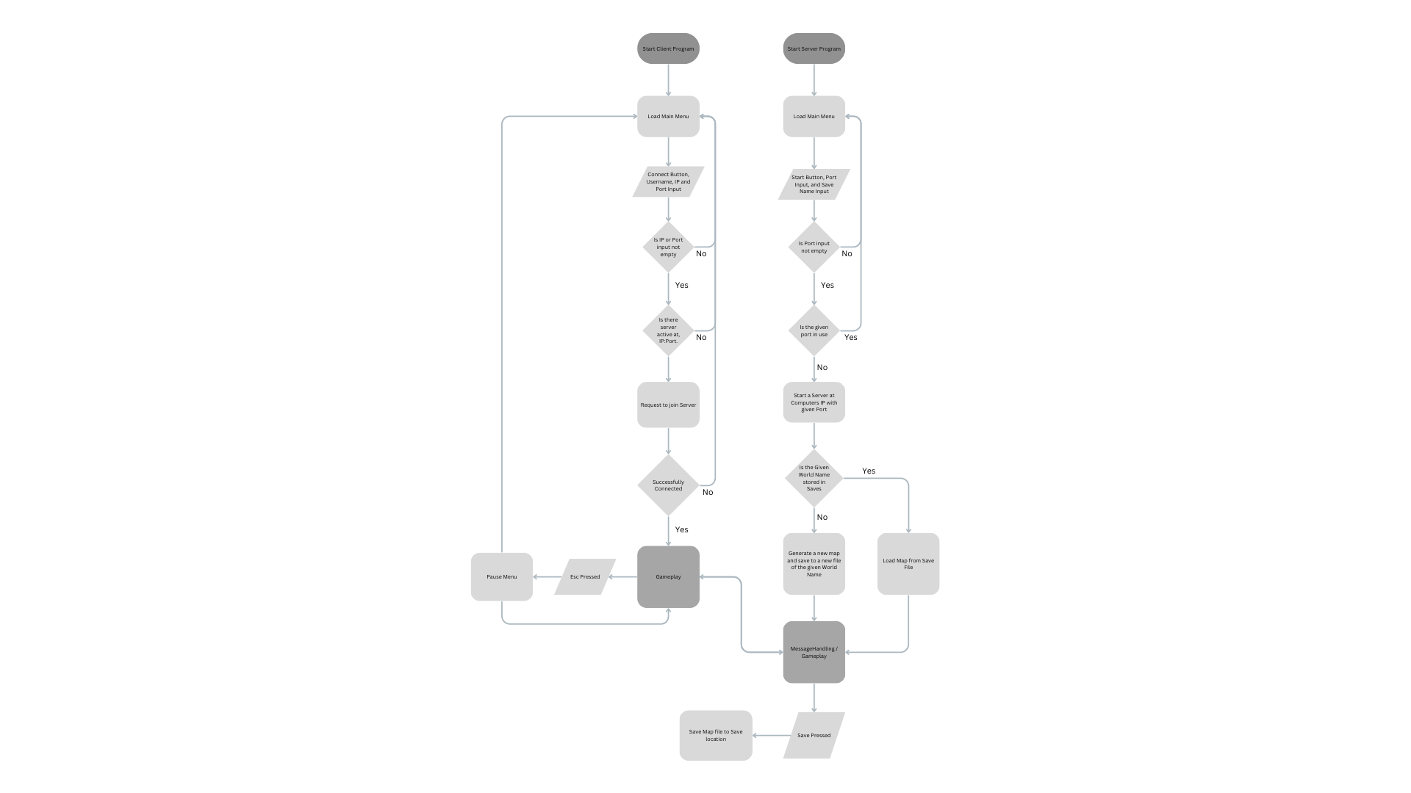**System Flowchart**

**Unity Engine Framework**

Within any unity script, derived from UnityEngine.MonoBehaviour there are predetermined methods such as:

* The Method Start(), that runs on an entities’ first frame.
* The Method Away(), that runs before an entity is loaded into a scene.
* The Method Update(), that runs on every frame.
* The Method FixedUpdate(), that runs 60 times per second.

Most importantly within unity, individual scripts, and other components can be placed onto objects within a game scene. These include colliders, physics bodies (known as a RigidBody) as well as textures.

**Required Runtime Data**

|  |  |  |
| --- | --- | --- |
| Player GameObject | | |
| Data Name/ Access Name | Data Type | Represents |
| transform.postition | Vector3 | Position of the player in the scene |
| transform.scale | Vector3 | The overall scale of the player in the scene |
| transform.localScale | Vector3 | The scale of the player relative to its current scale |
| playerHealth | integer | Current player health |
| inventory | Integer array | An array of the current block held in the inventory |
| hasAxe | bool | Whether the player has a Pickaxe |
| hasSword | bool | Whether the player has a Sword |
| itemHolding | integer | The ordinal number for the inventory array |
| ScreenToWorldPoint(Input.mousePosition) | Vector3 | Returns the position of the mouse in relation to its position in the physical scene |
| velocity | integer | The velocity of the player in the scene |
| OnGround | bool | A physics overlap at the players feet to determine if they are on the ground |
| Id | ushort | The players Id in the scene |
| IsLocal | bool | Whether the player is the Local player |

|  |  |  |
| --- | --- | --- |
| Zombie GameObject | | |
| Data Name/ Access Name | Data Type | Represents |
| transform.postition | Vector3 | Position of the entity in the scene |
| transform.scale | Vector3 | The overall scale of the entity in the scene |
| transform.localScale | Vector3 | The scale of the entity relative to its current scale |
| playerInViewRange | bool | Whether a player is in sight range |
| PlayerInAttackRange | bool | Whether there’s a playing the attacking range |
| closestPlayer | Vector3 | The closest player entity to the zombie |
| Id | ushort | The Id of the zombie in the scene |

|  |  |  |
| --- | --- | --- |
| Input field Component | | |
| Data Name/ Access Name | Data Type | Represents |
| text | string | The text held in the interactable area |
| position | Vector2 | Position on the UI canvas |

|  |  |  |
| --- | --- | --- |
| Button Component | | |
| Data Name/ Access Name | Data Type | Represents |
| DisplayText | string | The text held in the text area |
| position | Vector2 | Position on the UI canvas |
| colour | Color | The colour applied to the texture of the button |

|  |  |  |
| --- | --- | --- |
| Tile Component | | |
| Data Name/ Access Name | Data Type | Represents |
| TileMap | TileMap | The tilemap the tile belongs to. |
| Tile | RuleTile | The current tile being rendered |
| position | Vector2 | The position of the tile in the TileMap’s grid |
| tilemapCollider | Collider | The physics collider of the tile |

|  |  |  |
| --- | --- | --- |
| Hud Component | | |
| Data Name/ Access Name | Data Type | Represents |
| text | string | The text held in the text area |
| position | Vector2 | Position on the UI canvas |
| texture | Texture | Current rendered texture |

**Asset Requirements**

Text fonts used will be acquired from [www.dafont.com](http://www.dafont.com), specifically using fonts that are completely royalty free, all fonts used will be credited in the source tracker.

All textures are of my own making, made using Adobe Photoshop.

Design

**Function Abstraction – From Flowchart**

|  |  |
| --- | --- |
| Server | |
| Function | Definition |
| Load Main Menu | All Menu Components, and background images in the scene are enabled, input text boxes are unlocked |
| Request to Start Server | Port Number is taken in from the input field and passed into the constructer for the Server class |
| Generate New Map | Landscape and Rock seeds are randomly generated. Empty 2D array of map size and width is generated. Perlin noise-based generation function and cellular automata cave generation function is run. This is copied to the 2d array and then rendered to the Tile map. |
| Load Map from Save | A new Stream Reader is created, then this cycles through each line of the save .txt file and the added to the 2D map array. |
| Save Map | A new Stream Writer is created. Foreach row in the 2D map array, the content of the row is written to the file with StreamWriter.Write(). |
| Gameplay | Many functions will run on gameplay, MessageHandling will include syncing player positions, block placing and breaking, in addition to passing the map file between the server and client upon joining. |

|  |  |
| --- | --- |
| Client | |
| Function | Definition |
| Load Main Menu | All Menu Components, and background images in the scene are enabled, input text boxes are unlocked |
| Request to Join | Port number and IP address will be taken in as a ushort and string from the input fields. All menu Components are disabled, and input fields are locked. A request is sent to join any server at the given Ip and Port. This will return a bool; a failed connection will reload the Main Menu. |
| Gameplay | First the map will be loaded from the server and then a player spawned. Positions of the local player and any modifications made to the map will be sent to the server. |
| Pause Menu | Pressing the Esc key will toggle the pause menu. On a press, all pause menu components will be enabled and all player controlling scripts will be disabled. This will allow a player to resume or leave the server, returning them to the main menu. |

**User Interface Diagram**

Throughout the design phase, I have sent various diagrams, algorithms, and interface designs to Elliot, my client, to see if he thinks they meet the objectives, or if they need to be improved on. I will have different versions of these throughout the document.

Here’s the initial and final designs for the user interface; main menu and HUD.

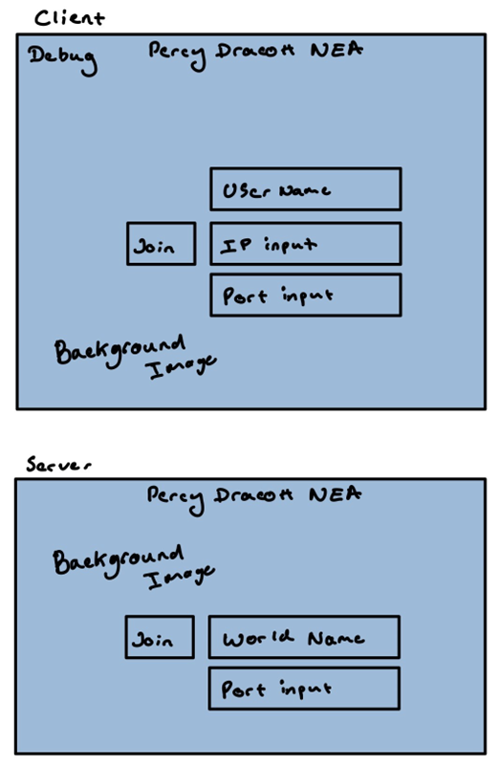

The Main menu scene of both the client and server applications will obviously contain a few collections of graphics, including text components, buttons, and input fields. These will all need to be unloaded when a game is started.

The HUD layout, as planned is below,

The HUD layout contains a prototype for the inventory system, where the player can scroll through items represented by the shaded square. Each element on the HUD drawing will be rendered above the gameplay. Below the crafting icon, which will toggle the ‘crafting’ element, is the health bar which will display the hp of the local player.

**Algorithms**

I’ve given each algorithm a rough difficulty level to implement, easy, medium, or hard – the harder algorithms may need more revisions as other elements of the design, such as data structures or data storage, develop.

**Map Generation**

As I’ve made a world generation prototype, I will go over the procedures and functions contained in that first.

|  |  |  |
| --- | --- | --- |
| Name: Generation | Definition: Overall function that call each part of the generation script, and initialises the map | |
| Input: worldWidth, worldHeight | | Output: N/A |
| Subroutine Generation(worldWidth, worldHeight)  ForgroundTileMap.ClearAllTiles()  BackgroundTileMap.ClearAllTiles()  Seed = Random.WithinRange(0,1000)  StoneSeed = Random.WithinRange(0,1000)  CaveSeed = Random.WithinRange(0.02,0.05)  OreSeed = Random.WithinRange(0.03,0.05)    map = new int[worldWidth,worldHeight]  If IsFromSave()  LoadMap()  SaveMap()  else  OptimisedTerrainGeneration(map, worldWidth, worldHeight, GrassSoil, Stone)  ApplyCaves(map);  AddTrees(TreePopulation, TestTileFG, Log, Leaf)  Endif    Renderer(map, TestTileFG, TestTileBG)  GenerateSaveFile(worldName)  SaveMap()  endSubroutine | | |
| Relevant Objective: 2.1 | | Time Complexity: O(1) |
| Difficulty: medium | | |

|  |  |  |
| --- | --- | --- |
| Name: TerrainGeneration | Definition: A function that creates the soil and stone layer of the map, in addition to adding ores. This is done in a loops per column of the map for efficiency. | |
| Input: worldWidth, worldHeight, worldMap, GrassTexture, StoneTexture | | Output: N/A |
| Subroutine TerrainGeneration(worldWidth, worldHeight, worldMap, Grass, Stone)  perlinNoiseSoil = 0  perlinNoiseStone = 0  For x = 0, x < worldWidth, x++  perlinNoiseSoil = RoundToInt(PerlinNoise(x / (smoothness), Seed) * worldHeight / 5)  perlinNoiseSoil += worldHeight / 3  For y = 0, y < perlinNoiseSoil, y++  worldMap[x,y] = 1  Endfor  perlinNoiseStone = RoundToInt(PerlinNoise(x / (smoothness), StoneSeed) * worldHeight / 8)  perlinNoiseStone += worldHeight / 4  For y = 0, y < perlinNoiseStone, y++  worldMap[x,y] = 2  Endfor  For y = 0, y < perlinNoiseSoil, y++  PerlinNoiseOre = RoundToInt(PerlinNoise(x * OreSeed, y * OreSeed))  If PerlinNoiseOre <= OreThreshhold  map[x,y] = 3  Endif  Endfor  Endfor  endSubroutine | | |
| Relevant Objective: 2.1 | | Time Complexity: O(n^2) |
| Difficulty: medium | | |

**Adding Caves**

Adding Caves was specified by my clients as a major aspect of the generation system, therefore Elliot and I had, many conversations to find the most appropriate generation system that fitted with his expectations.

|  |  |  |
| --- | --- | --- |
| Name: ApplyCaves Version 1 | Definition: Function that cuts caves out of the 2D array map file. | |
| Input: worldWidth, worldHeight, worldMap | | Output: N/A |
| Subroutine ApplyCaves(worldWidth, worldHeight, worldMap)  For x = 0, x < worldWidth, x++  For y = 0, y < worldHeight, y++  PerlinNoiseCave = RoundToInt(PerlinNoise(x * CaveSeed, y * CaveSeed))  If PerlinNoiseCave >= CaveThreshhold  map[x,y] = 0  Endif  Endfor  Endfor  endSubroutine | | |
| Relevant Objective: 2.2 | | Time Complexity: O(n^2) |
| Difficulty: easy | | |

|  |  |  |
| --- | --- | --- |
| Name: ApplyCaves Version 2 | Definition: Function that cuts caves out of the 2D array map file, using cellular automata | |
| Input: worldWidth, worldHeight, worldMap | | Output: N/A |
| Subroutine ApplyCaves(worldWidth, worldHeight, worldMap)  RandomFillGeneration()  Automata(iterations)    For x = 0, x < worldWidth, x++  For y = 0, y < worldHeight, y++  int topOfWorld = RoundToInt(PerlinNoise(x / (smoothness), Seed) * worldHeight / 5)  perlinNoiseSoil += worldHeight / 3  If cavemap[x, y] == 0 && y != 0 && y != topofworld - 1 && y != topofworld - 2  If map[x,y] == 1  map[x,y] = 8  Endif  If map[x,y] == 2 OR map[x,y] == 3  map[x,y] = 9  Endif  Endif  Endfor  Endfor  endSubroutine | | |
| Relevant Objective: 2.2 | | Time Complexity: O(n^2) |
| Difficulty: easy | | |

|  |  |  |
| --- | --- | --- |
| Name: RandomFillGeneration | Definition: Function that fills a 2D array randomly with a random fill percentage. | |
| Input: worldWidth, worldHeight | | Output: N/A |
| Subroutine RandomFillGeneration(worldWidth, worldHeight, caveMap)  caveMap = new int[worldHeight, worldWidth]  For x = 0, x < worldWidth, x++  For y = 0, y < worldHeight, y++  caveMap[x,y] = Random.WithinRange(0,100) < RandomFillPercentage ? 1 : 0  Endfor  Endfor  endSubroutine | | |
| Relevant Objective: 2.2 | | Time Complexity: O(n^2) |
| Difficulty: easy | | |

|  |  |  |
| --- | --- | --- |
| Name: Automata | Definition: Function that fills a 2D array randomly with a random fill percentage. | |
| Input: iterationCount, worldWidth, worldHeight | | Output: N/A |
| Subroutine Automata(iterations, worldWidth, worldHeight)  For i = 0, i < count, i++  int[,] tempMap = caveMap.Clone  For xs = 0, xs < worldWidth - 1, xs++  For ys = 0, ys < worldHeight - 1, ys++  int neighbours = 0  neighbours = GetNeighbours(tempMap, xs, ys, neighbours)  If neighbours > 4  caveMap[xs,ys] = 1  else  caveMap[xs,ys] = 0  Endif  Endfor  Endfor  Endfor  endSubroutine | | |
| Relevant Objective: 2.2 | | Time Complexity: O(n^2) |
| Difficulty: hard | | |

|  |  |  |
| --- | --- | --- |
| Name: GetNeighbours | Definition: Finds the number of neighbouring active cells in the array, around a given point. | |
| Input: tempMap, xs, ys, neighbours | | Output: int neighbours |
| Subroutine GetNeighbours(tempMap, xs, ys, neighbours)  For x = xs - 1, x <= xs, x++  For y = ys - 1, y <= ys, y++  If y <= worldHeight AND x <= worldWidth  If y != ys AND x != xs  If tempMap[x,y] = 1  neighbours++  Endif  Endif  Endif  Endfor  Endfor  Return neighbours  endSubroutine | | |
| Relevant Objective: 2.2 | | Time Complexity: O(1) |
| Difficulty: medium | | |

**Adding Trees**

Adding Trees was also pointed out by Elliot for part of the world generation, in addition this opens avenues for weapon crafting and addition building blocks that can be obtained through crafting, such as the plank block.

Elliot notes that have blocks of multiple colours and textures is important for keeping builds looking interesting.

This algorithm ensures that trees are not placed atop each other, by checking the position of each past tree. This is done by looping through the positions of all placed trees and subtracting the x-coordinate of a proposed tree, from the position of a placed tree, and ensuring that the absolute value of the sum is greater than 6; as this is the padding value given so trees aren’t overly clustered.

|  |  |  |
| --- | --- | --- |
| Name: AddTrees | Definition: Adds a given number of trees to the surface of the terrain, without placing then atop one another | |
| Input: worldWidth, worldHeight, DensityCount | | Output: N/A |
| Subroutine AddTrees(worldWidth, worldHeight, Map, density)  //Check for overpopulation  If density >= worldWidth / 6  density = worldWidth / 6  Endif  int temporaryX = 0  int[] positionHistory = new int[density]    For i = 0, x < density, i++  bool collisionAvoidance = true  While(collisionAvoidance)  int holdingPositionVariable = Random.WithinRange(2, worldWidth - 2)  collisionAvoidance = false  For j = 0, j <= i, j++  If AbsoluteValue(holdingPositionVariable - positionHistory[j]) < 6  collisionAvoidance = true  Endif  Endfor  If collisionAvoidance == False  temporaryX = holdingPositionVariable  Endif  Endwhile  positionHistory[i] = temporaryX    int temporaryY = worldHeight - 1  While Map[temporaryX,temporaryY - 1] == 0  temporaryY--  Endwhile    Map[temporaryX,temporaryY] = 4  Map[temporaryX, temporaryY + 1] = 4  Map[temporaryX, temporaryY + 2] = 5  Map[temporaryX, temporaryY + 3] = 5  Map[temporaryX, temporaryY + 4] = 5  Map[temporaryX + 1, temporaryY + 2] = 5  Map[temporaryX - 1, temporaryY + 2] = 5  Map[temporaryX + 1, temporaryY + 3] = 5  Map[temporaryX - 1, temporaryY + 3] = 5  Map[temporaryX + 1, temporaryY + 4] = 5  Endfor  endSubroutine | | |
| Relevant Objective: 2.3 | | Time Complexity: O(n!) |
| Difficulty: hard | | |

|  |  |  |
| --- | --- | --- |
| Name: Renderer | Definition: Function that takes the 2D map array and displays the content to the Tile map | |
| Input: worldWidth, worldHeight, worldMap | | Output: N/A |
| Subroutine Renderer(worldMap)  ForgroundTileMap.ClearAllTiles()  BackgroundTileMap.ClearAllTiles()  For x = 0, x < worldMap.GetHorizontalLength, x++  For y = 0, y < worldMap.GetVerticalLength, y++  If worldMap[x,y] == 1  ForgroundTileMap.SetTile(new Vector3Int(x,y,0), GrassSoil)  BackgroundTileMap.SetTile(new Vector3Int(x,y,0), GrassSoilBackground)  Endif  If worldMap[x,y] == 2  ForgroundTileMap.SetTile(new Vector3Int(x,y,0), Stone)  BackgroundTileMap.SetTile(new Vector3Int(x,y,0), StoneBackground)  Endif  If worldMap[x,y] == 3  ForgroundTileMap.SetTile(new Vector3Int(x,y,0), Ore)  BackgroundTileMap.SetTile(new Vector3Int(x,y,0), StoneBackground)  Endif  If worldMap[x,y] == 4  ForgroundTileMap.SetTile(new Vector3Int(x,y,0), Log)  Endif  If worldMap[x,y] == 5  ForgroundTileMap.SetTile(new Vector3Int(x,y,0), Leaf)  Endif  If worldMap[x,y] == 6  ForgroundTileMap.SetTile(new Vector3Int(x,y,0), Plank)  Endif  If worldMap[x,y] == 8  BackgroundTileMap.SetTile(new Vector3Int(x,y,0), GrassSoilBackground)  Endif  If worldMap[x,y] == 9  BackgroundTileMap.SetTile(new Vector3Int(x,y,0), StoneBackground)  Endif  Endfor  Endfor  endSubroutine | | |
| Relevant Objective: 2.1 | | Time Complexity: O(n^2) |
| Difficulty: easy | | |

**Map Saving and Loading**

Elliot notes that the ability to save and load past maps is important, as it will enable him and his friends to spend multiple sessions on one project.

|  |  |  |
| --- | --- | --- |
| Name: SaveMap | Definition: Function that saves the 2D map array to a file | |
| Input: worldMap | | Output: N/A |
| Subroutine SaveMap(worldMap)  Using StreamWriter sw = new StreamWriter($"WorldSaves/{worldName}/worldSave.txt")  For y = 0, y < worldMap.GetVerticalLength, y++  For x = 0, x < worldMap.GetHorizontalLength, x++  sw.Write(worldMap[x,y])  Endfor  sw.WriteLine()  Endfor  EndUsing  endSubroutine | | |
| Relevant Objective: 5.1 | | Time Complexity: O(n^2) |
| Difficulty: medium | | |

The map will be located in a save folder: WorldSaves/{worldName}/worldSave.txt, where worldName is a string variable passed in from the input fields upon starting a server.

|  |  |  |
| --- | --- | --- |
| Name: LoadMap | Definition: Function that fills an empty 2D array with the map data. | |
| Input: worldMap | | Output: N/A |
| Subroutine LoadMap(worldMap)  int y = 0  Using StreamReader sr = new StreamReader($"WorldSaves/{worldName}/worldSave.txt")  string value  While (value = sr.ReadLine()) != Null  For x = 0, x < worldMap.GetHorizontalLength, x++  worldMap[x,y] = ConvertToByte(value[x]) - 48  Endfor  y++  Endwhile  EndUsing  Renderer(worldMap)  endSubroutine | | |
| Relevant Objective: 5.1 | | Time Complexity: O(n^2) |
| Difficulty: medium | | |

The following two functions will be used on the server application to check if a map is being loaded from a save of is new, and then create the saving directory if necessary.

|  |  |  |
| --- | --- | --- |
| Name: GenerateSaveFile | Definition: Function that creates the file saving directory upon loading a new world, not a previous save. | |
| Input: worldName | | Output: N/A |
| Subroutine GenerateSaveFile(worldName)  if File.Exists($"WorldSaves/{worldName}") == false  Directory.Create($"WorldSaves/{worldName}")  Endif  endSubroutine | | |
| Relevant Objective: 5.1 | | Time Complexity: O(1) |
| Difficulty: easy | | |

|  |  |  |
| --- | --- | --- |
| Name: IsFromSave | Definition: Function that returns a Boolean if the given world name has a file directory | |
| Input: worldName | | Output: Boolean |
| Subroutine Bool IsFromSave(worldName)  if File.Exists($"WorldSaves/{worldName}")  return true  else  return false  Endif  endSubroutine | | |
| Relevant Objective: 5.1 | | Time Complexity: O(1) |
| Difficulty: medium | | |

**Player Control and Spawning**

Local players will need to be controlled by the player, interact with the world, and have a health system.

Each of the following function will be part of PlayerController.cs, a script that will be run on the local player in a scene.

|  |  |  |
| --- | --- | --- |
| Name: xMovePlayer | Definition: Function that uses the keyboard input though unity and sets the velocity of the player. This function is called in the Update() Function of unity. | |
| Input: N/A | | Output: n/A |
| Subroutine xMovePlayer()  float moveX = Input.GetInputsFromAxis("Horizontal")  Vector2 movement = new Vector2(moveX,0)  if PlayerIsOnGround()  Player.Velocity = movement * speedValue  ElseIf PlayerIsOnGround() == false AND moveX != 0  Player.Velocity = moveX * speedValue / 2  Endif  endSubroutine | | |
| Relevant Objective: 1.1 | | Time Complexity: O(1) |
| Difficulty: easy | | |

|  |  |  |
| --- | --- | --- |
| Name: PlayerBreakingBlock | Definition: Function that uses the mouse position in the world to remove a block at its given position, with an amount of time based on the type of block. A call for this function will be run in Update(), if the mouse button is depressed. | |
| Input: timeMining, mousePos | | Output: n/A |
| Subroutine PlayerBreakBlock(timeMining, mousePos)  if timeMining == 0  Vector2 mousePosOnCall = new Vector2(truncate(mousePos.x), truncate(mousePos.y))  Endif  if mousePosOnCall = new Vector2(truncate(mousePos.x), truncate(mousePos.y))  timeMining += Time.DeltaTime //Counts the time since a frame where Time.DeltaTime wasn't called.  if timeMining > AmountOfTimeToBreak()  BreakBlock()  timeMining = 0  Endif  Else timeMining = 0  Endif  endSubroutine | | |
| Relevant Objective: 1.5 | | Time Complexity: O(1) |
| Difficulty: medium | | |

|  |  |  |
| --- | --- | --- |
| Name: AmountOfTimeToBreak | Definition: Function that takes the mouse position, to find the type of block in the 2D map array at the position. Returning the amount of time, it takes to break the block, at the requested position. | |
| Input: mousePos | | Output: float |
| Subroutine float AmountOfTimeToBreak(mousePos)  float timetobreak = 0  Switch (Map.ReturnBlockType(new Vector2(truncate(mousePos.x), truncate(mousePos.y))))  Case 1  timetobreak = 0.6f  break  Case 2  timetobreak = 1.8f  break  Case 3  timetobreak = 1.8f  break  Case 4  timetobreak = 1f  break  Case 5  timetobreak = 0.2f  break  Case 6  timetobreak = 1f  break  Default  timetobreak = 1  break  EndSwitch  if player.HasAxe  return timetobreak / 2f  Else  return timetobreak  Endif  endSubroutine | | |
| Relevant Objective: 1.5 | | Time Complexity: O(1) |
| Difficulty: easy | | |

The additional features functions, of player inventory loading and saving are planned out below.

|  |  |  |
| --- | --- | --- |
| Name: SavePlayerState | Definition: Function that save the players inventory, items, and position to a file. | |
| Input: worldName, PlayerID | | Output: n/A |
| Subroutine SavePlayerState(worldName, PlayerID)  Using StreamWriter sw = new StreamWriter($"WorldSaves/{worldName}/{PlayerID}.txt")  For i = 0, i < inventory.Length, i++  sw.WriteLine(inventory[i])  Endfor  sw.WriteLine(transform.positon.x)  sw.WriteLine(transform.positon.y)  if Player.HasAxe  sw.WriteLine("1")  Else  sw.WriteLine("0")  Endif  if Player.HasSword  sw.WriteLine("1")  Else  sw.WriteLine("0")  Endif  EndUsing  endSubroutine | | |
| Relevant Objective: 1.5 | | Time Complexity: O(1) |
| Difficulty: medium | | |

|  |  |  |
| --- | --- | --- |
| Name: LoadPlayerState | Definition: Function that takes a save file and fills the players inventory, items, and position. | |
| Input: worldName, PlayerID | | Output: n/A |
| Subroutine LoadPlayerState(worldName, PlayerID)  string value  int i = 0  float tempx  float tempy  Using StreamReader sr = new StreamReader($"WorldSaves/{worldName}/{PlayerID}.txt")  While (value = sr.ReadLine()) != null  if i < 10  inventory[i] = Convert.ToInt16(value)  Endif  if i == 10  tempx = (float)Convert.ToDouble(value)  Endif  if i == 11  tempy = (float)Convert.ToDouble(value)  Endif  if i == 12 AND value == "1"  Player.HasAxe = True  Else  Player.HasAxe = False  Endif  if i == 13 AND value == "1"  Player.HasSword = True  Else  Player.HasSword = False  Endif  i++  Endwhile  transform.positon = new Vector2(tempx, tempy)  EndUsing  endSubroutine | | |
| Relevant Objective: 1.5 | | Time Complexity: O(1) |
| Difficulty: medium | | |

**Zombie Control and Spawning**

Zombie movement will be handled by the server, and positions will be passed to the clients. Zombie attacks, however, will be calculated client side as the zombie will attack when a player is within range, as guided by the server’s movement.

|  |  |  |
| --- | --- | --- |
| Name: IdlePatrol | Definition: Function that directs a zombie on a patrolling walk when a player is not in range | |
| Input: playerInRange, patrolRange | | Output: n/A |
| Subroutine IdlePatrol(playerInRange, patrolRange)  float lengthOfTime = walkSpeed * patrolRange  if (patrolRange > 0) AND !playerInRange  timeSinceActive += Time.deltaTime;  if timeSinceActive > 2 * lengthOfTime  timeSinceActive -= 2 * lengthOfTime  Endif  if timeSinceActive > lengthOfTime  zombieRB.velocity = new Vector2(walkSpeed * transform.localScale.x, zombieRB.velocity.y)  Else  zombieRB.velocity = new Vector2(-walkSpeed * transform.localScale.x, zombieRB.velocity.y)  Endif  Endif  timeSinceActive = 0  endSubroutine | | |
| Relevant Objective: 1.5 | | Time Complexity: O(1) |
| Difficulty: medium | | |

|  |  |  |
| --- | --- | --- |
| Name: PlayerInRangePositon | Definition: Function that returns the position of the closest player to the zombie, within sight range. | |
| Input: playerInRange, patrolRange | | Output: Vector2 |
| Subroutine Vector2 playerInRangePosition()  Vector2 closePlayer = new Vector2(0,0)  float previousDistance = sightRange  If playerInRange  Colliders[] players = (Physics2D.OverlapCircleAll(transform.position, sightRange, playerLayer)  float currentDistance  Foreach var item in players  currentDistance = item.Magnitude //The overall distance of the Vector2, when treated as a coordinate Vector2  If currentDistance < previousDistance  closePlayer = item.transform.position  previousDistance = currentDistance  Endif  EndForeach  Endif  Return closePlayer  endSubroutine | | |
| Relevant Objective: 1.5 | | Time Complexity: O(1) |
| Difficulty: medium | | |

**Client and Server Scripts**

**Miscellaneous Scripts**

**UI and HUD**

**Textures and Animations**

As listed in Objective 6.1 and 6.2, the art style of the project is important to my client, Elliot has noted that the art style should be consistent throughout, taking inspiration from games of the late 80s and early 90s, in addition to the newer wave of retro looking games.

Here’s the final texture for each asset in the game, as mentioned in **Asset Requirements** all assets are produced by myself.

**Player Texture**